August '15

Liberty eSignature
User Guide

Table of Contents
Quick Start Guide 3
General Usage Notes 3
Messages 4
Navigation 4
eSignature Overview 4
Workflow setup 5
Sending New Account Paperwork 6
Forms 6
eSignature Steps 6
Select Account Forms 7
Select Proposals 7
Upload Other Forms 8
Enter Recipients 9
Confirmation 10
DocuSign Workflow 11
Phone Authentication 12
Envelopes 13
Appendix A 14

Quick Start Guide
eSignature in Liberty is offered through an integration with DocuSign. Using eSignature in Liberty requires a two-step setup process to establish your user profile and credentials. Please work with your Relationship Manager to request access to eSignature.
- Fill out the eSignature setup form to establish your workflow, providing a list of required and optional reviewers or approvers and their email addresses.
- Once your DocuSign user profile has been established, you will receive an account activation email from DocuSign. Click on the link to activate your account.
- Your eSignature account will be activated in Liberty after your DocuSign account is created.
- eSignature can be initiated from the Forms page under the Account Registration process and the Envelopes.
- Real time status updates are found on the Envelopes page under the Documents tab or by logging directly into DocuSign at: https://na2.docusign.net/Signing/?ti=152ab264cbd849328366490f24a1aecb

General Usage Notes
- Always tab off of or click off of a field after entering data. This tells the Liberty application that you are done entering data in the field and allows it to validate the entry.
- Unlike TCAdvisor, you will be able to edit certain information without clicking an Edit button.
- Error and Informational messages are generally displayed at the top of the screen and contain helpful information regarding errors or actions about to be taken. Please pay special attention to these messages as you complete actions within Liberty.
- Liberty has the same robust user authorizations as TCAdvisor so we can tailor user access to authorize only those areas you deem appropriate.
- As with most web-based applications, you should use the navigation options provided within Liberty rather than your browser’s back button.
- Reset and Cancel actions will not save your changes. Reset will clear any entered data and allow you to start over. Cancel will exit the modification screen without saving your changes. Always tab off of fields after entering information to make sure the information is recorded appropriately.
- Continue saves your changes and automatically navigates you to the next step.
- Save commits your changes. Information is not saved unless you see the confirmation message
- Cancel exits a screen without saving any changes.

Messages
There are several messages you will see as you perform actions within Liberty. In general, messages appear at the top of the screen with a colored background.
Informational messages appear with a blue background and an “I” icon. These messages typically confirm that you have successfully completed some action.
Critical messages appear with a red background and an ‘x’ icon. These messages indicate that something needs to be corrected before you can proceed.

Navigation
The tabs at the top of your screen define major areas of functionality within Liberty
The Documents tab is where you can access DocuSign Envelopes. The appearance and available options may vary depending on your role.

eSignature Overview
eSignature is offered through DocuSign and can be used to have clients sign off on new account paperwork, including their Transfer form. Additional forms, such as Asset Management Agreements or Broker/Dealer paperwork can also be included for signature in the digital envelope of documents that the client will receive. Phone authentication is used to help validate a client’s identity when signing paperwork. These documents will be stored on DocuSign’s servers and accessed through the Liberty platform.

Workflow setup
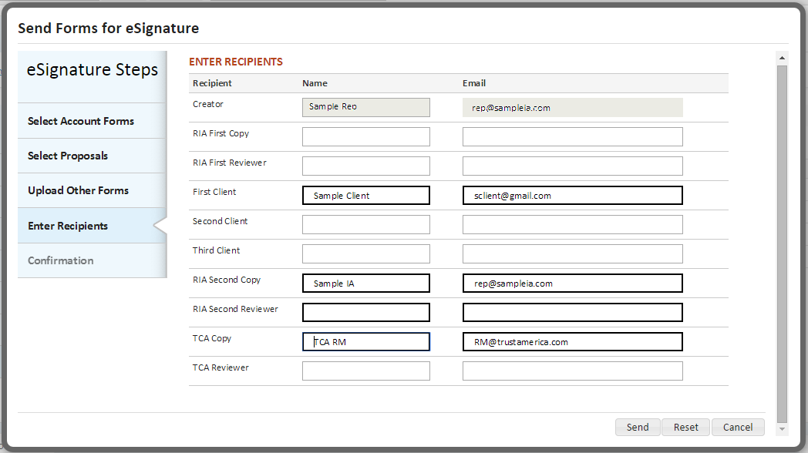
The workflow can be customized based on your specific needs. At each stop in the workflow, you have the option to either review and/or approve the document. You can choose to do this before and/or after the client signs the documents. Once setup, your Envelope recipients will default to using this information.
Using eSignature in Liberty requires a two-step setup process to establish your user profile and credentials in both DocuSign’s system and in Liberty. Please work with your Relationship Manager to request and submit an eSignature Setup form.

Sending New Account Paperwork

Forms
When in the Registration Steps, the Forms screen lets you print pre-populated forms in order to complete the account opening process.
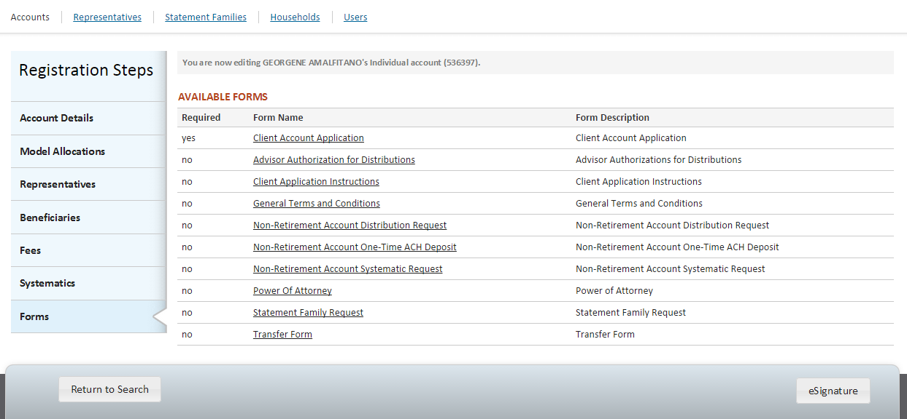
The Available Forms table will list the forms pertinent to the type of client account being created. Click on the Form Name link to review and print the forms. Select eSignature to create an electronic envelope and send form(s) to your client(s) for review.

eSignature Steps

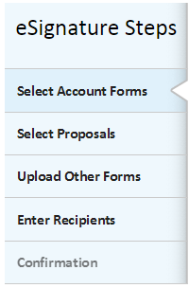
You will be walked through the eSignature process in a series of short steps:
- Select the pre-populated TCA forms for inclusion in your envelope.
- Upload other documents, such as asset management agreements or broker-dealer paperwork.
- Enter or review the envelope recipients and send it out for eSignature
- Receive confirmation that your envelope has been successfully sent

Select Account Forms
- You will be presented with a list of all TCA forms available for inclusion in the envelope.
  - Required forms must be included
- Select additional forms via checkbox
- Indicate the number of copies of each form to include in the envelope
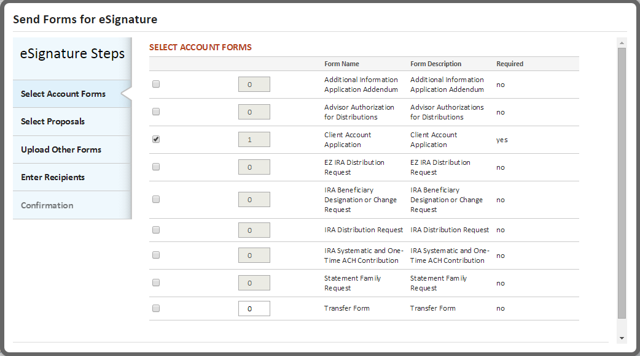

Select Proposals
- A list of proposals associated to the account will be presented. Add documents to the Envelope via check box.

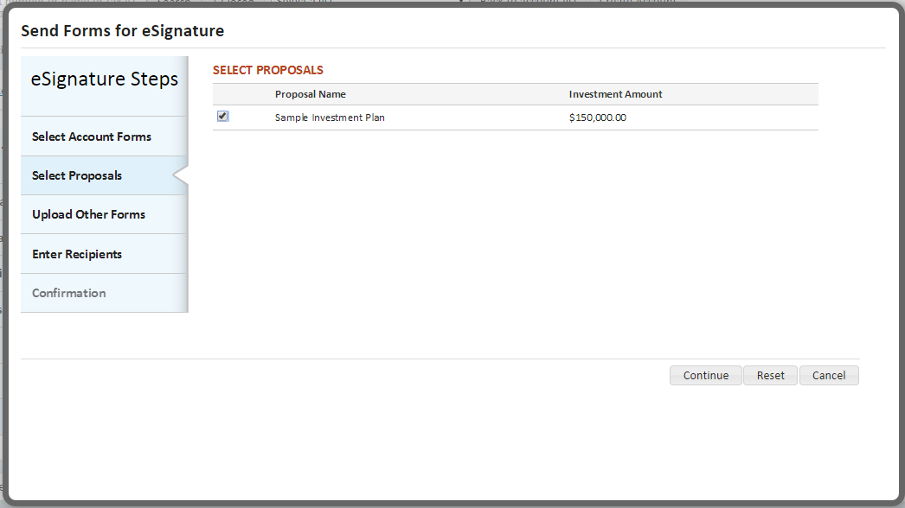

Upload Other Forms
- Clicking the Choose button will bring up a window that allows you to upload documents you have saved on your computer or network drive. See Appendix A for instructions on adding a signature tag to these forms. Here are some examples of the types of forms you may want to include for eSignature:
  - Prefilled via LaserApp
  - Marketing Materials
  - Advisory agreements
  - Broker – Dealer paperwork
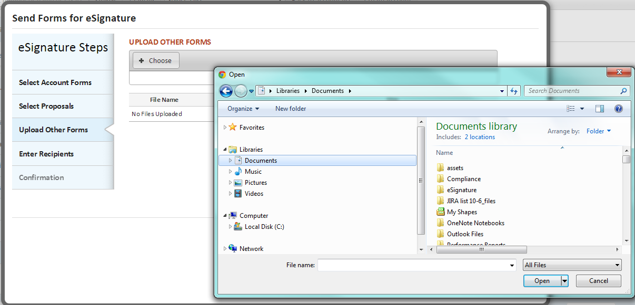

Enter Recipients
- Setting up your eSignature workflow was done when establishing your account, eliminating the need to enter this information.
- Email information for your clients will be pre-populated from the Contact record and/or Account Details screen.
- You will need to enter phone information for your clients so the DocuSign phone authentication process can be completed.
- Your workflow setting will determine what information can be edited.
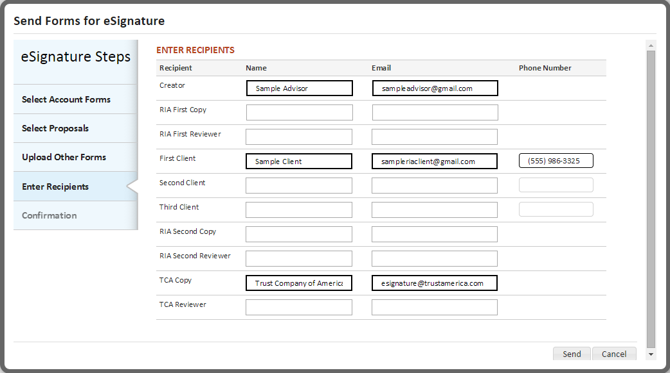

Confirmation
- You will receive an on screen success message once your envelope has been sent
- You can choose View Envelope and confirm signing
- You can Open Inbox to view the status of the envelope. This will bring you to the Envelopes page under the Documents tab
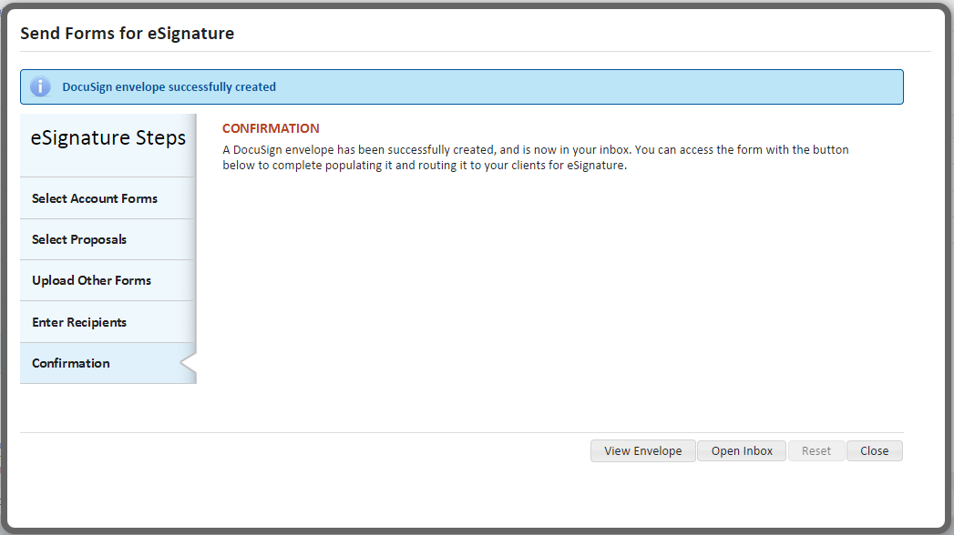

DocuSign Workflow
- The Envelope creator must first confirm signing.
  - This can be done by selecting the View Envelope button on the Confirmation page.
  - It can also be done from the Envelopes section of the site.
- You can edit or add new information to the form.
- You can review all documents that have been included in the Envelope.
- When ready, Confirm Signing.
- Once Confirm Signing is clicked, the document cannot be changed.
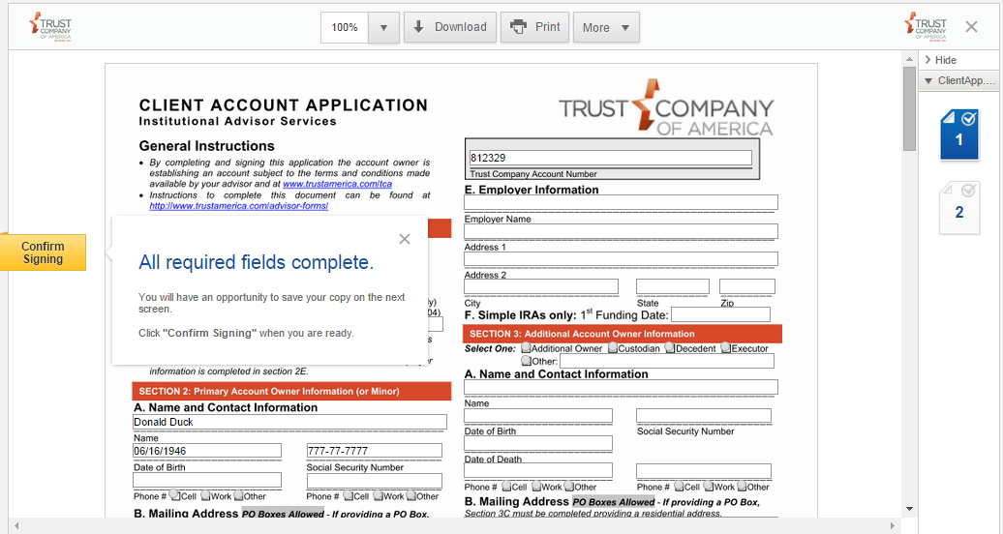

Phone Authentication
- In order to provide a high level of security on eSignatures, the investor will be required to authenticate their identity via phone.
- The client will receive an email notifying them that they have documents ready to be signed electronically. Once the client chooses to View Documents they will be redirected to a page that outlines the phone authentication process:
  - The client will receive a call from DocuSign where they will be required to:
    - Enter the pin number they received from DocuSign
    - State their name while DocuSign records, creating a digital “thumb print”
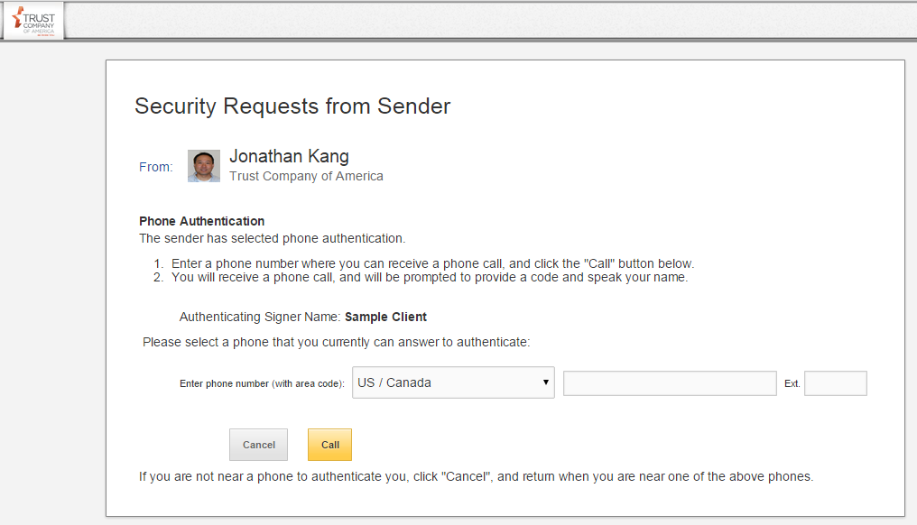

Envelopes
The Envelopes screen under the Documents tab provides access to a list of envelopes that have been sent for eSignature.
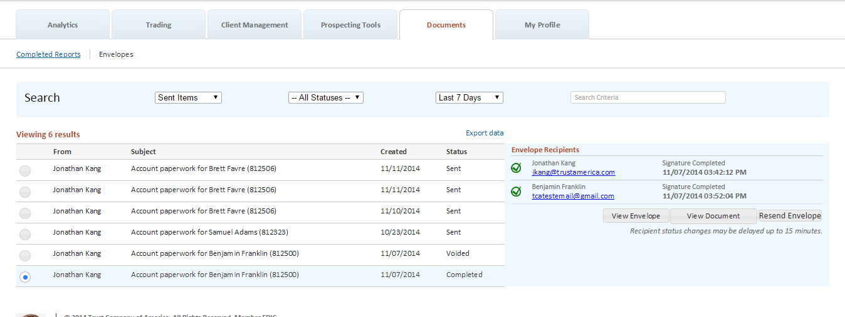
The summary table shows:
- From: The Envelope sender
- Subject: Identifies the account for which paperwork was sent
- Created: The date the envelope was created
- Status: Displays the current status of the envelope, from:
  - Sent
  - Voided
  - Completed
- Selecting an envelope will display a list of recipients, along with the status for each sender.
- The Signature Pending status is used when the Envelope has been sent to the recipient but signature has not yet been obtained.
- The Signature Completed status for an individual recipient will also show the date and time of the signature.

Appendix A
Electronic signatures can be applied to documents that are uploaded to an Envelope by following a few simple steps. For each person set up as a signer in the workflow, you will be able to tag the form to collect a signature, the date signed and the name of the signer. This will typically be done for clients but can also be leveraged to collect signatures from others, such as Compliance or a Broker/Dealer.
To have signatures applied to the document, the following needs to be done:
- Determine the roles that you want to apply to your documents. The current signer roles names that we have defined are:
- CREATOR
- RIA_SIGN1
- CLIENT1
- CLIENT2
- CLIENT3
- RIA_SIGN2
- RIA_SIGN3
- RIA_SIGN4

- You will need to add text to the document that is the same color as the document’s background.* This is done so DocuSign can read the text and insert the signature tag in the appropriate place without exposing the text to the signer.
  - <roleName>_SIGN
  - <roleName>_DATE
  - <roleName>_NAME

* In this example, the background and text are white. The text has been highlighted in blue to demonstrate how this should look.
