November 15

Liberty Generate Transfers
User Guide

Table of Contents
Quick Start Guide 3
General Usage Notes 3
Messages 3
Navigation 4
Generating Intermodel Transfers 4
Select Models 5
Select Method 5
Options 5
Options 5
Asset Selection 6
6
Select Accounts 6
Processing Intermodel Transfers 7

Quick Start Guide
Intermodel transfers allow Investment Advisors to create a bulk transfer of securities between models based on a list of accounts.
- Navigate to the Generate Transfers page
- Select the transferring model and receiving model
- Set the transfer method and define the asset percentage to transfer
- Select the assets to transfer
- Add accounts to include in the transfer
- Process the transfer

General Usage Notes
- Always tab off of or click off of a field after entering data. This tells the Liberty application that you are done entering data in the field and allows it to validate the entry.
- Unlike TCAdvisor, you will be able to edit certain information without clicking an Edit button.
- Error and Informational messages are generally displayed at the top of the screen and contain helpful information regarding errors or actions about to be taken. Please pay special attention to these messages as you complete actions within Liberty.
- Liberty has the same robust user authorizations as TCAdvisor so we can tailor user access to authorize only those areas you deem appropriate.
- As with most web-based applications, you should use the navigation options provided within Liberty rather than your browser’s back button.
- Reset and Cancel actions will not save your changes. Reset will clear any entered data and allow you to start over. Cancel will exit the modification screen without saving your changes. Always tab off of fields after entering information to make sure the information is recorded appropriately.
- Continue saves your changes and automatically navigates you to the next step.
- Save commits your changes. Information is not saved unless you see the confirmation message
- Cancel exits a screen without saving any changes.

Messages
There are several messages you will see as you perform actions within Liberty. In general, messages appear at the top of the screen with a colored background.
Informational messages appear with a blue background and an “I” icon. These messages typically confirm that you have successfully completed some action.
Critical messages appear with a red background and an ‘x’ icon. These messages indicate that something needs to be corrected before you can proceed.

Navigation
The tabs at the top of your screen define major areas of functionality within Liberty
The Trading tab is where you can access Generate Transfers. The appearance and available options may vary depending on your role.

Generating Intermodel Transfers
An intermodel transfer creates a bulk transfer of securities and/or cash between models, based on a list of accounts.
To generate a new intermodel transfer from the Trading tab, click on the Generate Transfers link. Information required to create the transfer will be shown in red on the screen.
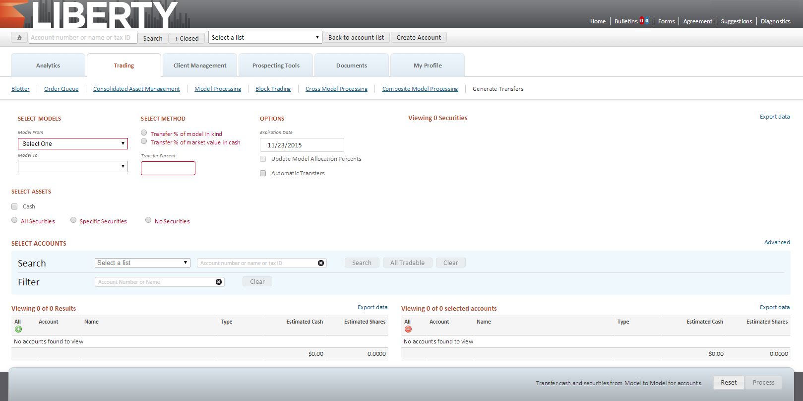
Select Models
- From Model: Select the model transferring out assets
- To Model: Select the model receiving the assets

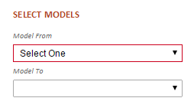

Select Method
- Transfer % of Model in Kind: Enter a percentage amount in the Transfer Percent field. This will determine the quantity of shares to transfer.
- Transfer % of Market Values in Cash: Enter a percentage amount in the Transfer Percent field. This creates a cash demand based on the current market value of the model
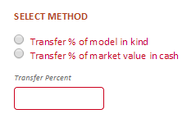

Options
- Expiration Date: The date which an unprocessed manual transfer should be removed. The default date will be 7 days from the current but can be extended as far as 14 days.
- Update Model Allocation Percents: Updates the allocation percentages in each account, including the allocation percent, contribution percent, and distribution percent, select box. Once the transfer is generated, an account will NOT automatically adjust for subsequent deposits or withdrawals.
- Automatic Transfers: When selected, the transfers will be automatically posted.

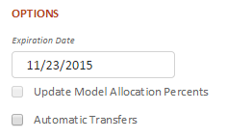

Asset Selection

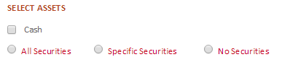
- Cash: Check the box to include cash
- All Securities: Select to include all securities in the transfer.
- Specific Securities: Select to include Specific Securities Selection in the transfer. Click the Lookup Security button to select the securities to include.
- No Securities: Select to only include cash in the transfers.

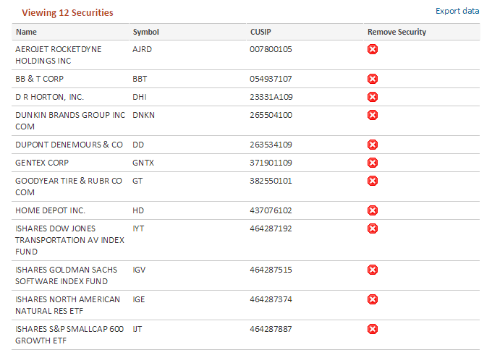

Select Accounts

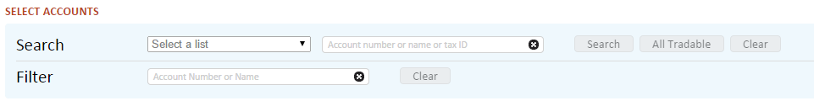
Search for accounts multiple ways:
- Select an Account List
- Enter a specific account number, name or tax ID
- Search for All Tradable accounts
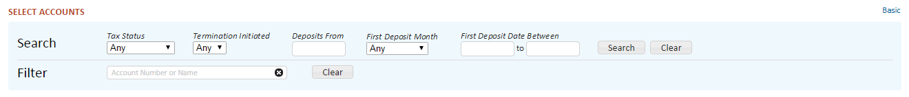
For more search options, click on the Advanced link and enter additional criteria. Filter results by Account Number or Name for easy selection.
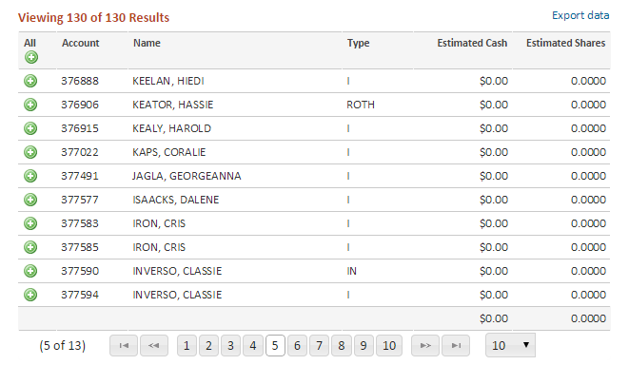
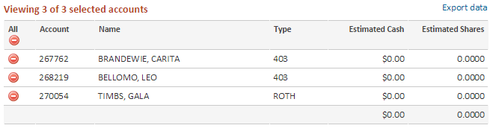
- Click the Add button for each account to include in the trade order
- To include all accounts, click the Add All button.
- View added accounts on the right side of the screen
- Remove accounts by clicking the red X

Processing Intermodel Transfers
Once all the required fields are filled in, the Process button is enabled in the Action Dock. A summary of the transfer will also be displayed in the Action Dock.
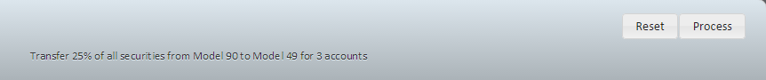
When the process is complete, the Intermodel Transfer Processing Summary will display. Successfully saved transfers will be listed, showing the details of each transfer. Any important messages or alerts affecting the transfer(s) will also be shown.
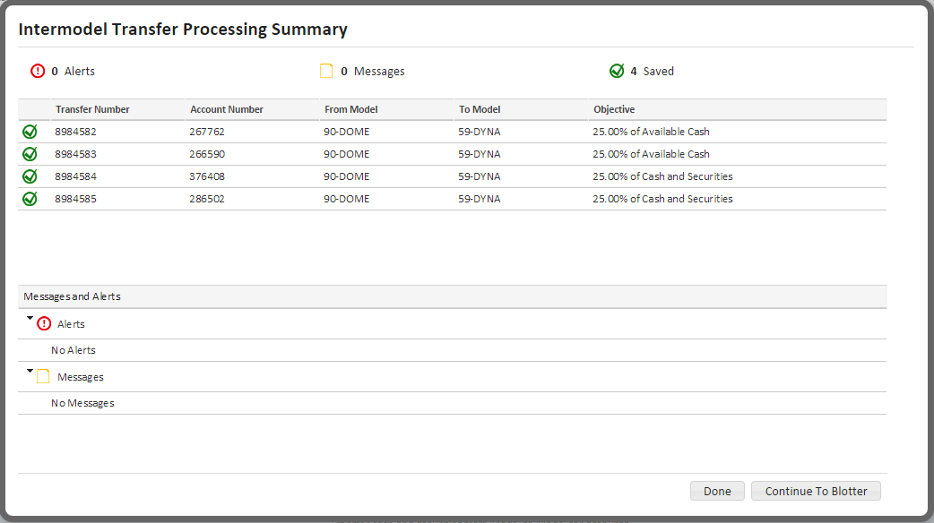
Either click the Done button to close the window, or Continue to Blotter, to review and approve the created trades.
