August 2015

Liberty Analytics
User Guide
Representative Edition

Table of Contents
Navigation 4
Averages Page 5
Information Icon 6
View Details 6
Year End Active Accounts 7
Year End Account Size 8
Year End AUM 9
Accounts Opened and Closed 10
Leaderboard Page 11
Leaderboard Table View 12
Leaderboard Periodicity 13
Leaderboard - Representative Name Display 14
Growth Page 15
Growth – Chart View 15
Growth – Detail View 15
Tablet Navigation 16
Business Rules 17
General 17
Account Changes 17
Accounts with Multiple Representatives 17

Navigation
The Overview tab has been renamed to Analytics. Functionality in the Summary page remains unchanged.
There are three new sub navigation links: Averages, Leaderboard, and Growth.
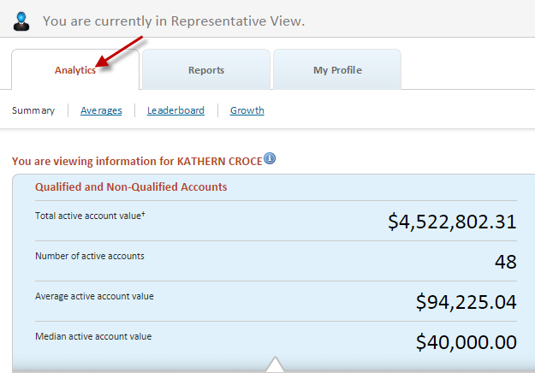

Averages Page
The Averages page provides snapshots of representatives’ performance at fixed points in time. It is made up of the following bar graphs:
- Year End Active Accounts
- Year End Account Size
- Year End AUM
- Accounts Opened and Closed
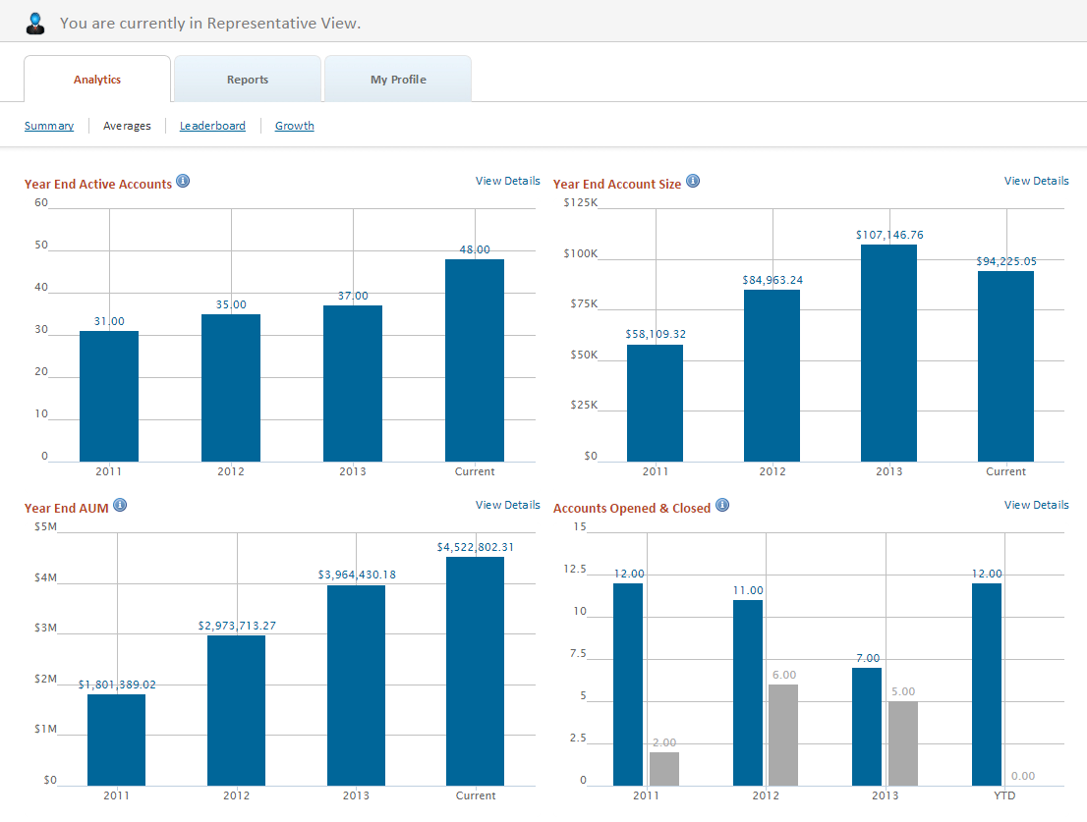

Information Icon
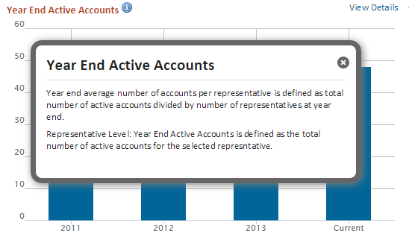
Each bar graph title contains an information icon which expands to display the data definition for the metric in question.

View Details
Click on the View Details link to view the underlying data of the bar graph.
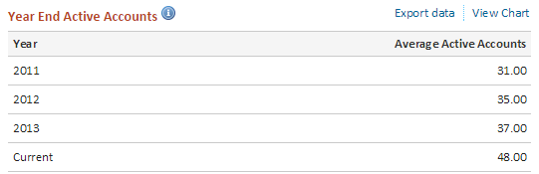

Year End Active Accounts

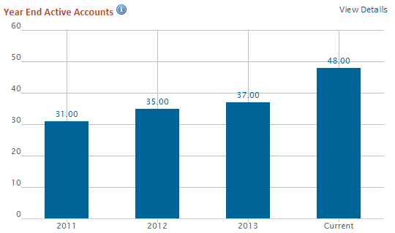
Year End Active Accounts is composed of the total number of active accounts for the selected representative.

Year End Account Size

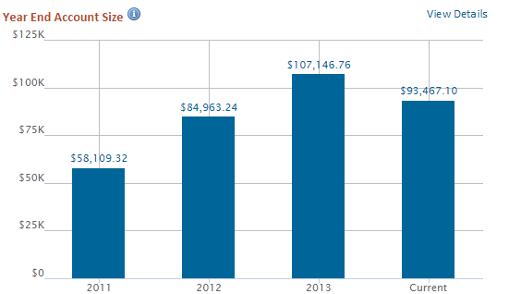
Year End Account Size is defined as the total value of a representative's accounts divided by the total number of representative accounts.

Year End AUM

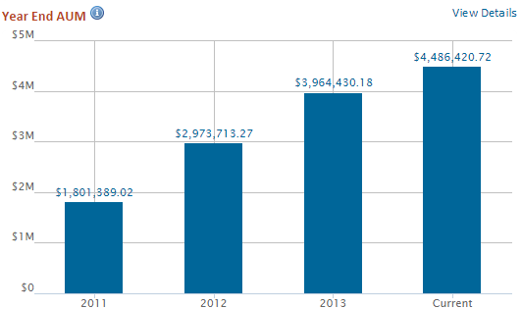
Year End AUM is composed of the total value of all active accounts for the selected representative.

Accounts Opened and Closed
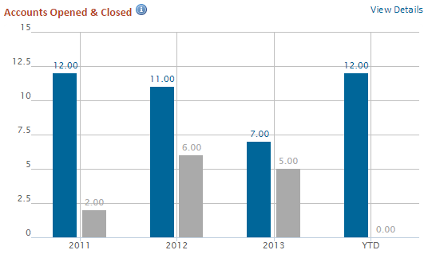
Accounts Opened and Closed is defined as the total number of accounts opened and closed for the selected representative.

Leaderboard Page
The Leaderboard page displays representative growth relative to their peers at the same firm. Ranking metrics are available for in both absolutes and percentage terms for the following items:
- AUM Dollar Growth
- AUM Percentage Growth
- Closed Accounts
- Gross Deposits
- Net Deposits
- Net New Accounts
- New Accounts
- Withdrawals
- Period Over Period Deposit Trends
- Period Over Period Net Deposit Trends
- Period Over Period New Account Trends
- Period Over Period Withdrawal Trends
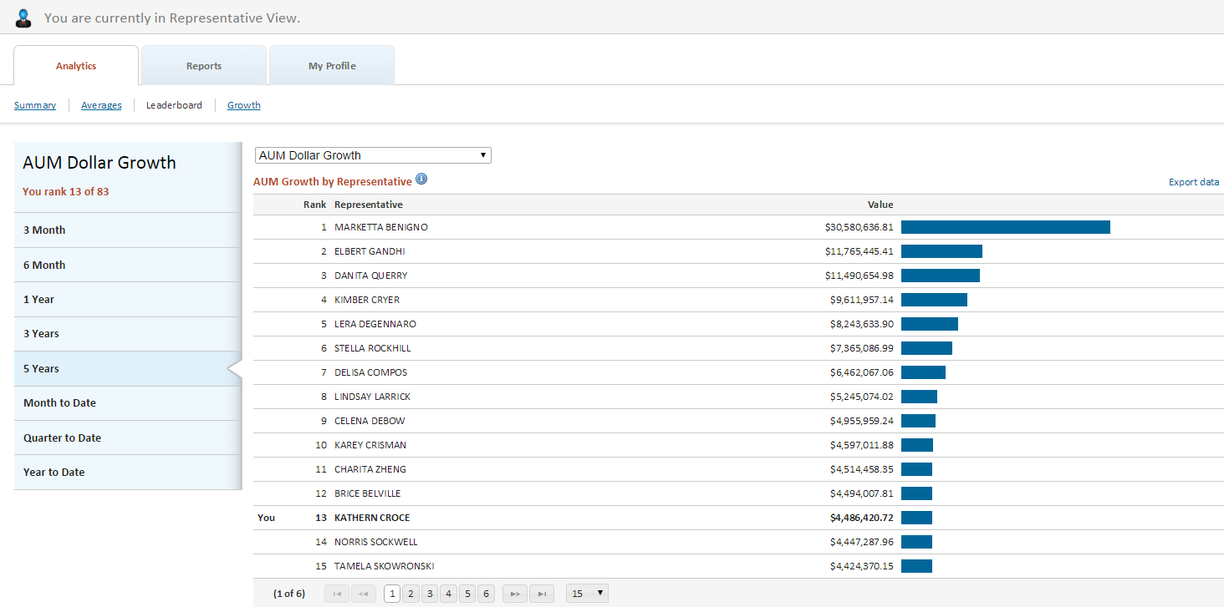

Leaderboard Table View
Each Leaderboard table is made up of the following items
- Rank – Your rank relative to your peers at the same RIA
- Your Name *
- Value – The Dollar or percent value of the selected metric
- Relative Performance Graph - A visual representation of the metric against a baseline of 100
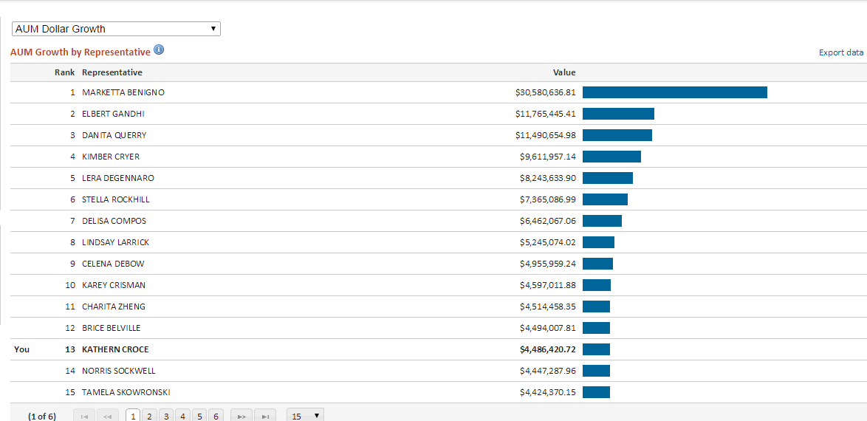

*Representative Name display is configurable and can be anonymized.

Leaderboard Periodicity
Available periods for metrics are displayed on the sidebar. The sidebar will adjust to the number of periods available for each specific metric.
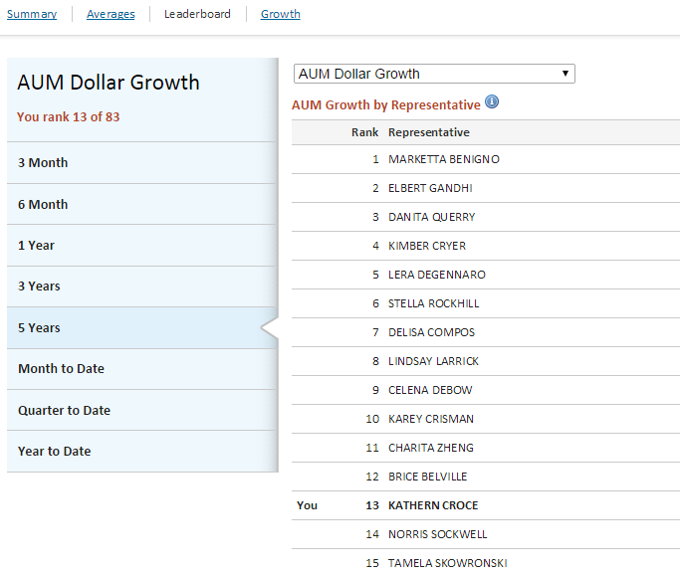

Leaderboard - Representative Name Display
Depending on configuration, representative names may be anonymized within the leaderboard page.

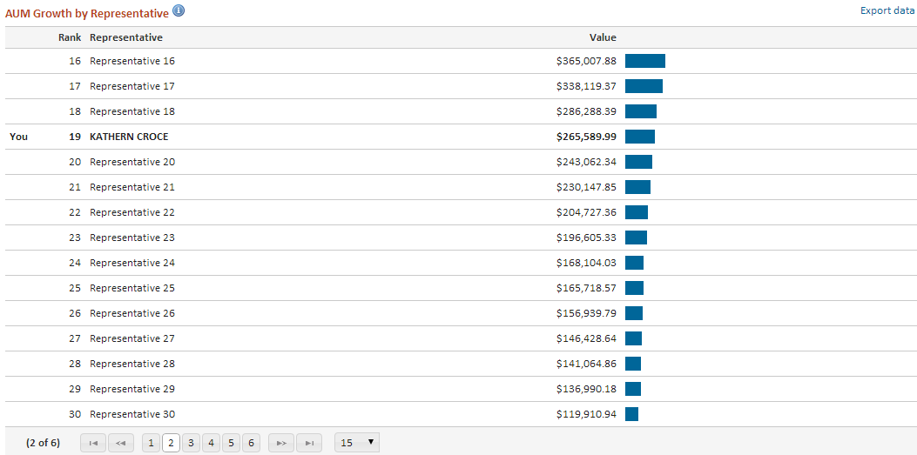

Growth Page
This section displays values for each month in the time period selected, and provides a view of performance over time. Growth metrics are available in both absolutes and percentage terms for the following items:
- AUM Growth Over Time
- Percentage AUM Growth Over Time
- Deposit Growth
- Withdrawal Growth

Growth – Chart View
The default view displays growth over time in chart format.

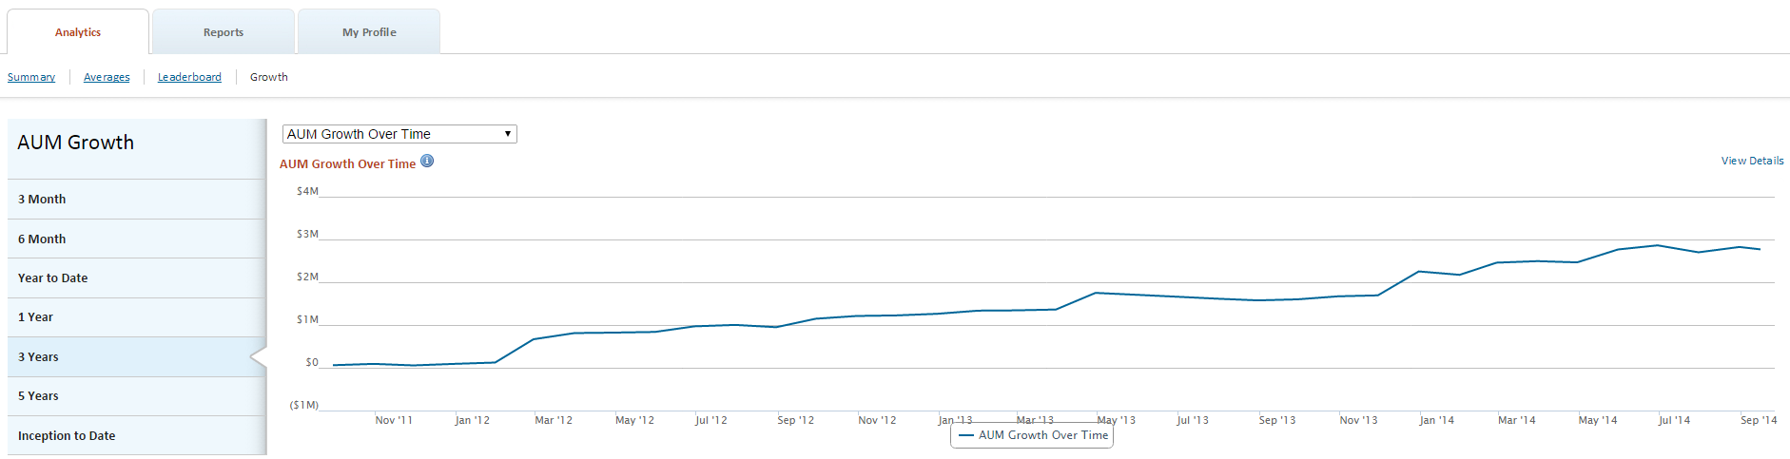

Growth – Detail View
Click on the View Details link to view the underlying data of the chart.

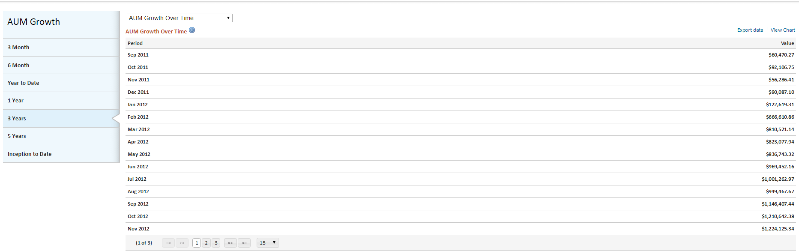

Tablet Navigation
The tablet version of Analytics retains all features and functionality of the desktop version.
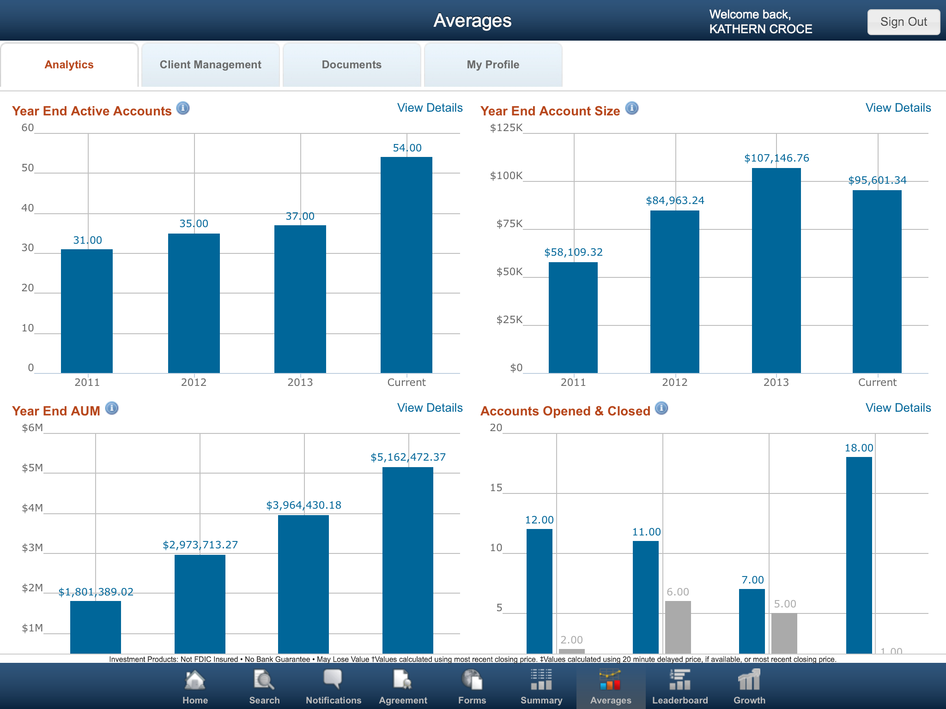

When viewing the Analytics tab on a tablet device, Averages, Leaderboard and Growth will appear as icons in the lower navigation bar. Tap the icons to view those pages. The icon will change from black and white to color to indicate the active page.

Business Rules

General
- Analytics data Incudes active, funded accounts only with no established term date.
- Representatives must have a minimum of one active account to be included in Analytics counts.
- Growth metrics are calculated only for representatives having data for the current period and at least one full prior period.
- Individual representative collations on the Averages page are totals rather than averages.

Account Changes
If an account is moved from one representative to another representative, the historic performance earned by the original representative will remain with that representative, although the current assets under management will be increased for the new representative and similarly decreased for the old representative.

This rule also applies at the Firm/Broker Dealer level, in the event that the new representative is associated with a different firm then the original representative. The system will not, however, count the event as an account closure under the old representative and account opening under the new representative.

Accounts with Multiple Representatives
On accounts with multiple representatives defined, the system will apportion deposits, withdrawals and market value based on the percent fee associated to each representative on the account. All representatives where the defined percent fee is greater than 0, however, will get credit for open accounts, closed accounts, etc. The system will automatically exclude special associated representatives that are only associated for the purpose of providing batch exports to other data services.

