Based on the preferences you previously selected, viewing of transactions is now consistent with my view of positions – if you chose to default the positions view to Trade, Statement or Post Date, the Transactions now view to the same option.

Depending on your current preference, transactions are defaulted to same selection and are displayed as follows:

- Transactions by Trade Date view:
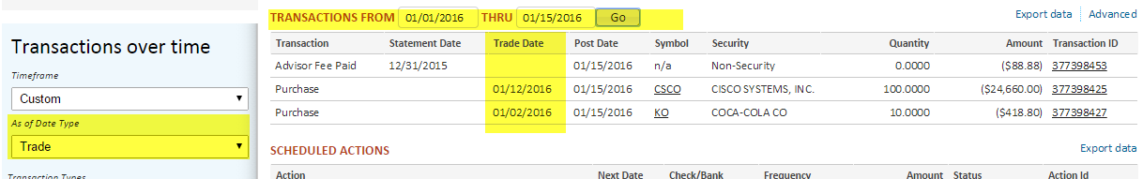
- Transactions by Post Date view:
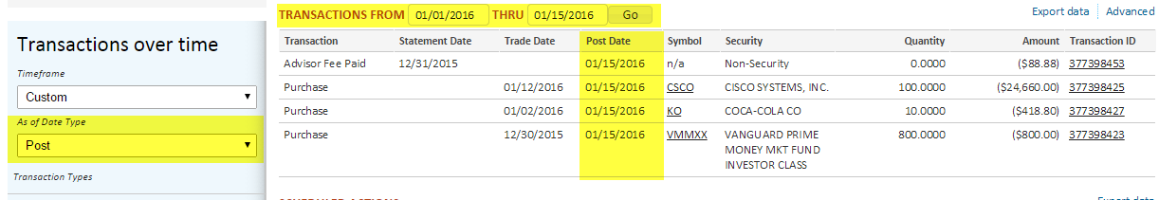
- Transactions by Statement Date view:
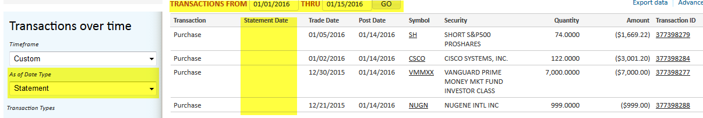

If you are considering changing your default selection, or have questions regarding this feature, let your relationship manager know.

